**Name: Victoria Jacqueline Macías Pico**

**W O R K S H E E T S**

**NOTE:** **Your answers must be in blue and bold.**

# UNIT 6



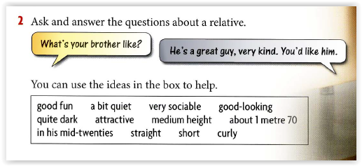

**Make 5 sentences using the words from the box.**

|  |  |
| --- | --- |
|  | Josselyn look like attractive today. |
|  | My twin brothers are like very social in the meetings. |
|  | She looks like a bit quiet. |
|  | That girl looks like short hair. |
|  | He looks like in his mid-twenties. |

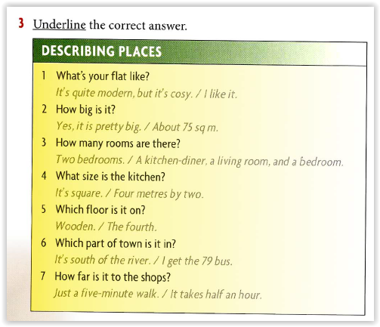

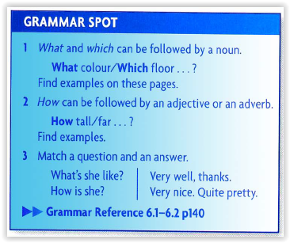

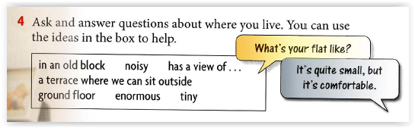

|  |  |
| --- | --- |
|  | What is you flat like? It is a ground floor and has a large backyard. |
|  | How big is it? I do not know, but it has an enormous backyard |
|  | What view do the bedrooms have? They have a view of the patio and the trees. |
|  | How big is the kitchen? It is tiny |
|  | What part of the city is it in? It is in a very noisy part, near the street. |
|  | Which floor receives visitors?  On a terrace where we can sit outside |
|  | Which floor do you keep things to clean the backyard? In an old block |

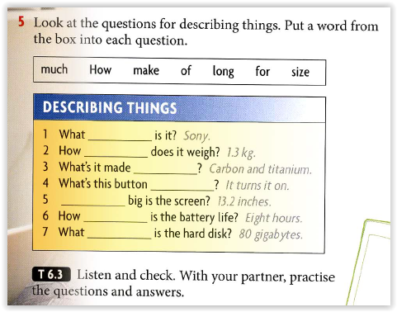

**Make**

**Much**

**Of**

**For**

**How**

**Long**

**Size**

**ADJECTIVES**

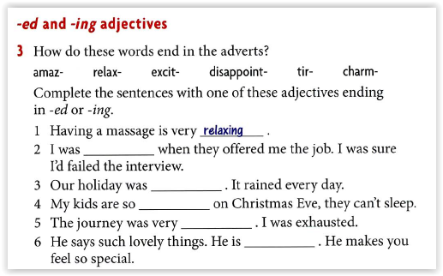

**Amazed**

**Disappointing**

**Excited**

**Tiring**

**Charming**

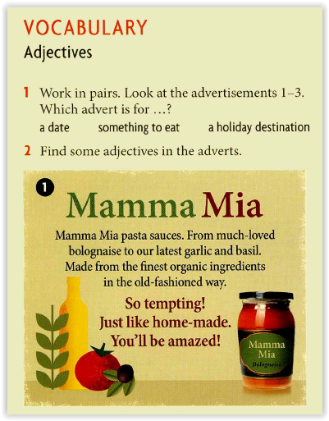

**ADVERBS**

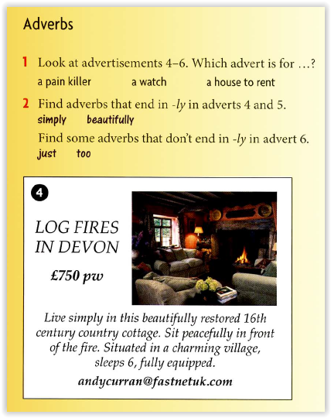

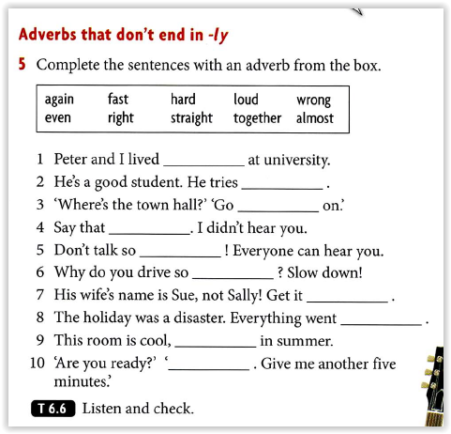

**Together**

**Hard**

**Straight**

**Again**

**Loud**

**Fast**

**Right**

**Wrong**

**Even**

**Almost**

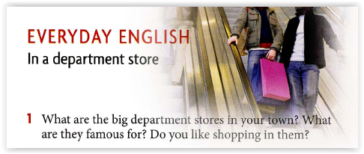

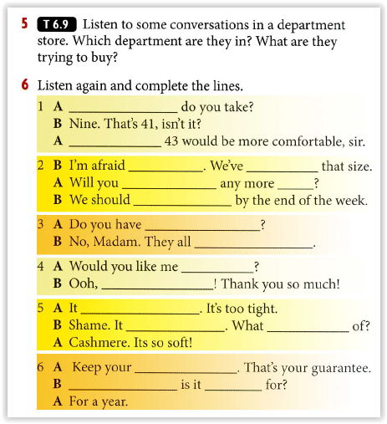

**What size**

**I think you’ll find**

**That’s all we have**

**Sould out of**

**Be getting**

**Be getting a delivery**

**Any sofas like this in stock**

**in**

**Have to be ordered**

**That would be lovely**

**To gift wrap it**

**Doesn’t fit me**

**Really suits you**

**It made**

**Receipt**

**How long**

**Guaranteed**

**2. Complete with the correct form of the verb. FIRST CONDITIONAL.**